**Project Design Phase-II**

**Data Flow Diagram & User Stories**

|  |  |
| --- | --- |
| Date | 31 January 2025 |
| Team ID | SWTID1741176034150337 |
| Project Name | NEWS APP |
| Maximum Marks | 4 Marks |
| TEAM MEMBERS | RINOSHA FATHIMA.S-[**rinoshafathima786@gmail.com**](mailto:rinoshafathima786@gmail.com) |
|  | JAYASHREE.R- [jayashreeanitha05@gmail.com](mailto:jayashreeanitha05@gmail.com) |
|  | MONIKA.S- [monikasankar2022@gmail.com](mailto:%20%20monikasankar2022@gmail.com) |
|  | RESHMA.S - reshmas24ug@gmail.com |
|  | KALAIVANI.M - kalaivanimohan20@gmail.com |

**Data Flow Diagrams:**

A Data Flow Diagram (DFD) is a traditional visual representation of the information flows within a system. A neat and clear DFD can depict the right amount of the system requirement graphically. It shows how data enters and leaves the system, what changes the information, and where data is stored.

**Example:**

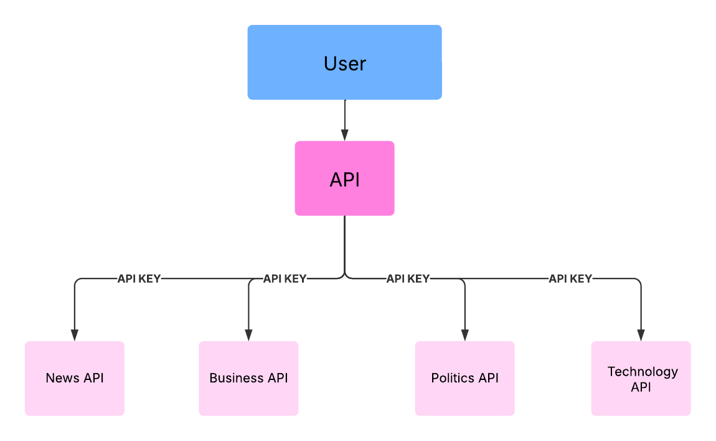

**User Stories**

**User Story Table – Music Streaming App**

|  |  |  |  |  |  |  |
| --- | --- | --- | --- | --- | --- | --- |
| **User Type** | **Functional Requirement (Epic)** | **User Story Number** | **User Story / Task** | **Acceptance Criteria** | **Priority** | **Release** |
| **News** |  | USN-1 | As a user, I can see the trendy news . | I can see the News of all topics. | High | Sprint-1 |
| **Genre** |  | USN-2 | As a user, I can watch Political,Business, and Technology News. | I can also go the source and read the full news. | High | Sprint-1 |
|  |  | USN-3 | As a user, I can able to view the complete news across the world. | I can also watch the news for multiple pages . | Medium | Sprint-2 |
| **Subscription** |  | USN-4 | As a user, I can even subscribe. | I can Subscribe to the newsletter for the news . | High | Sprint-2 |

**Project Design Phase-II**

**Solution Requirements (Functional & Non-functional)**

|  |  |
| --- | --- |
| Date | 31 January 2025 |
| Team ID | SWTID1741176034150337 |
| Project Name | NEWS APP |
| Maximum Marks | 4 Marks |
| TEAM MEMBERS | RINOSHA FATHIMA.S-[**rinoshafathima786@gmail.com**](mailto:rinoshafathima786@gmail.com) |
|  | JAYASHREE.R- [jayashreeanitha05@gmail.com](mailto:jayashreeanitha05@gmail.com) |
|  | MONIKA.S- [monikasankar2022@gmail.com](mailto:%20%20monikasankar2022@gmail.com) |

**Functional Requirements:**

Following are the functional requirements of the proposed solution.

**Functional Requirements – News App**

|  |  |  |
| --- | --- | --- |
| **FR No.** | **Functional Requirement (Epic)** | **Sub Requirement (Story / Sub-Task)** |
| **FR-1** | **News Home** | Top News |
| **FR-2** | **News Genre** | General,Health,Technology,Politics,Art & Culture |
| **FR-3** | **NewsLetter** | NewsLetter subscription |

**Non-functional Requirements:**

Following are the non-functional requirements of the proposed solution.

|  |  |  |
| --- | --- | --- |
| **NFR No.** | **Non-Functional Requirement** | **Description** |
| **NFR-1** | **Usability** | The app should have an intuitive and user-friendly interface, ensuring smooth navigation and accessibility for users of all demographics. |
| **NFR-2** | **Security** | User authentication and data must be secured using encryption (e.g., HTTPS, OAuth for third-party logins). The app should prevent unauthorized access and follow best security practices. |
| **NFR-3** | **Reliability** | The app should ensure a consistent and uninterrupted music streaming experience, minimizing crashes and downtime. |
| **NFR-4** | **Performance** | Songs should load and stream with minimal buffering. The app should respond to user interactions (search, playback, playlist management) within 2 seconds. |
| **NFR-5** | **Availability** | The system should maintain an uptime of at least 99.9%, ensuring accessibility across different time zones. |
| **NFR-6** | **Scalability** | The app should handle increasing numbers of users and concurrent streams efficiently without performance degradation. The architecture should support future feature expansion. |

**Project Design Phase-II**

**Technology Stack (Architecture & Stack)**

|  |  |
| --- | --- |
| Date | 31 January 2025 |
| Team ID | SWTID1741176034150337 |
| Project Name | News App |
| Maximum Marks | 4 Marks |
| TEAM MEMBERS | RINOSHA FATHIMA.S-[**rinoshafathima786@gmail.com**](mailto:rinoshafathima786@gmail.com) |
|  | JAYASHREE.R- [jayashreeanitha05@gmail.com](mailto:jayashreeanitha05@gmail.com) |
|  | MONIKA.S- [monikasankar2022@gmail.com](mailto:%20%20monikasankar2022@gmail.com) |

**Technical Architecture:**

The Deliverable shall include the architectural diagram as below and the information as per the table1 & table 2

**Example:** News App

**Table-1 : Components & Technologies:**

|  |  |  |  |
| --- | --- | --- | --- |
| **S.No** | **Component** | **Description** | **Technology** |
|  | User Interface | Web-based interface for News | HTML, CSS, JavaScript / React Js etc. |
|  | Application Logic-1 | News fetching from News api | React js |
|  | Application Logic-2 | News fetching based on genre | React js |

**Table-2: Application Characteristics:**

|  |  |  |  |
| --- | --- | --- | --- |
| **S.No** | **Characteristics** | **Description** | **Technology** |
|  | Open-Source Frameworks | Frontend frameworks | React.js, BootStrap, Tailwind CSS |

**References:**

[**React.js Documentation**](https://react.dev/)